A Cash First Approach to Food Poverty:
Developing regional ‘Money Counts’ Training.

This guide was developed by the Highlands Money Counts Partnership with Transformation Cornwall, and Independent Food Aid Network (IFAN).
The guide is designed to help those who have attended the Scottish Training for Trainers course for Money Counts Level 1, develop their own training for frontline services. The training uses the IFAN ‘Worrying About Money’ leaflet as a resource. If your local area does not have a current IFAN leaflet, links can be made with IFAN to take forward the co-development of a leaflet in your area.

The learning outcomes for the course are:
- Increase understanding of poverty and its impact
- Increased confidence to ask about money worries
- Increase knowledge of support services for money matters

The course is 45 minutes long and delivered on Teams but any online platform can be used.

Longer term evaluation has been carried out in the Highlands at 4 month post training, results showing:
Training increased participants confidence to ask about money worries:
neutral 5%; agree 58%; strongly agree 37% (no disagree)
Training increased participants knowledge about money support services:
neutral 5%; agree 48%; strongly agree 47% (no disagree)

The training slides have been created using Powerpoint and have been branded to echo the design of the lFAN Worrying About Money leaflets.
Creating your regional slides:
- Replace all images of the leaflet on the slide deck with images of your regional leaflet
- Replace all references to Highland services with your regional leaflet services
- Create your logo group for each slide, we suggest a key training organisation having a slightly larger logo with the key leaflet and/or training partners smaller & to the right.

Information on polling participants for confidence and knowledge and the creation of an attendance certificate have been detailed in a separate document.

There are several slides and messages which form the core values of the course and it would be recommended you keep these. These have been detailed in the following script.

From delivering the training in Highland, a maximum group of 10 for the session has worked well.

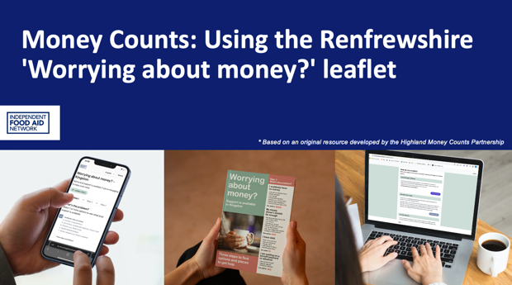 | Please keep the reference to the Highlands Partnership as the original source  Logos from partners involved with the training can be added on this and following slides.
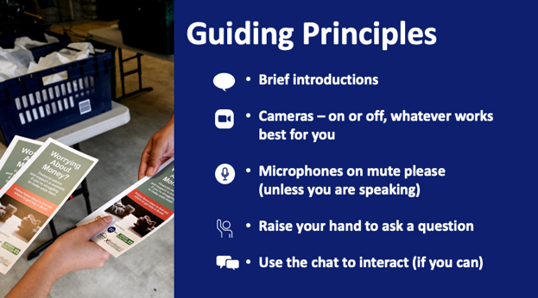
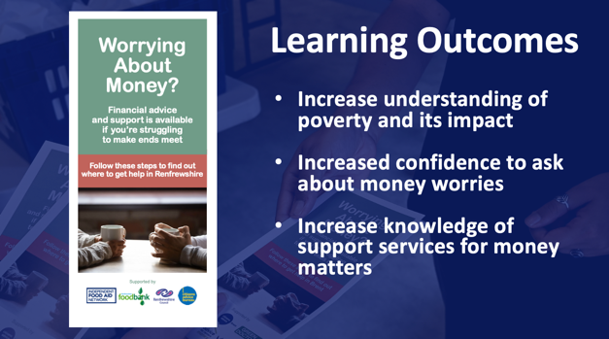 | Please keep this slide and highlight your key training outcome.  Our key aims of today are to set the course in the context of poverty and to increase confidence and knowledge to ask about money worries
This slide can be replaced with information on the polling format you are using but it is important to ask for confidence and knowledge levels pre and post course and to use this to monitor effectiveness of the training.
(Information on polling options provided at the end of the document)

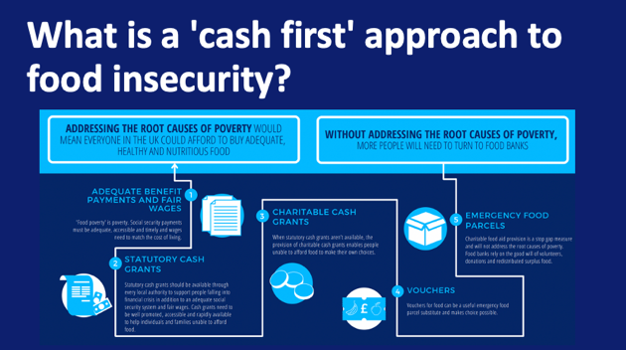  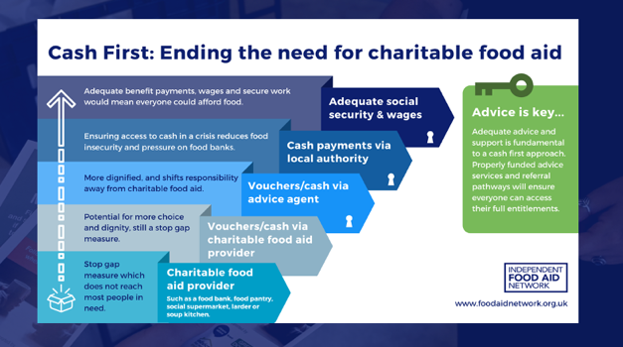 | This section talks about a cash first approach to food insecurity. And how charitable food aid is a sticking plaster and not a solution to the poverty driving someone to need help from a food bank. A cash first approach aims to wherever possible address the poverty behind the need for someone to use a food bank through income-based solutions. Enabling choice and dignity for people facing financial crisis. A cash first approach looks at maximising people’s incomes whether from paid work or social security payments.
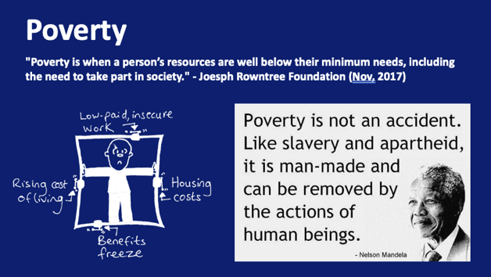 | Please keep this slide  There are many definitions of poverty but this is a simple and straightforward one.  The first quote from the Joseph Rowntree Foundation highlights that we need money to take part in society and doesn’t just reference money as something we need to pay for services and bills.  The second – read quote is a short and simple one from Nelson Mandela. ‘  It highlights that poverty is man-made – that through collective action society has created it – but through collective action we can also help to impact on it too.  Think about what we use our income for? What things are basic necessities (food, heat, shelter) and what are luxuries? Is a mobile phone a luxury, having access to the internet, being able to socialise?  If for example you are applying for Universal Credit, you have to do this online and then you are expected to job search online, keep a journal which work coaches can access and these all need broadband. You can get free internet access in place like the job centre, libraries and work clubs but that means getting to these places if you can and they may not be easily accessible in remote and rural areas.  Can you name some types of poverty? (use hands-up or the chat function).  Other types of poverty mentioned include: digital poverty, rural poverty, societal poverty, housing poverty, transport poverty, funeral poverty.  Poverty no matter what name we give it is still poverty – this is a key message of the training.  There is sometimes a big emphasis on child poverty but in order for a child to be in poverty, the adult that cares for them must be in poverty. It can be helpful to think of different types of poverty to recognise the depth and breadth of the problem but we need to tackle it as a whole.
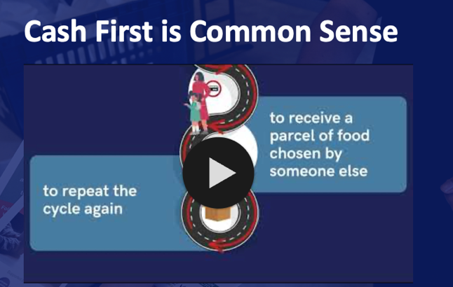 | This short video rounds up the start of the session – cash first and poverty
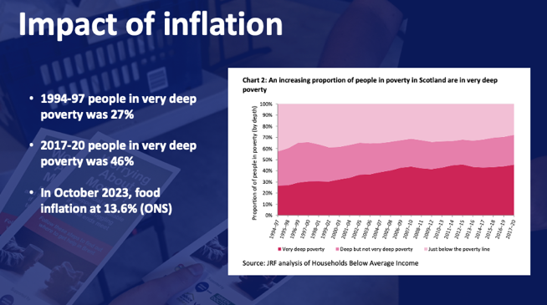  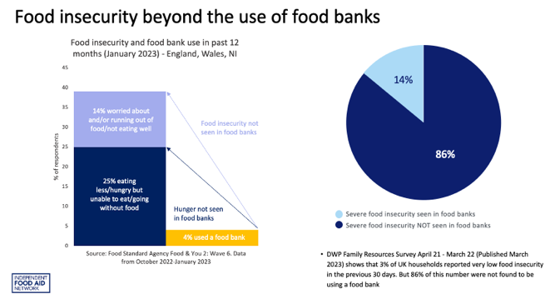 | Please keep this slide  These slides are adapted depending on the session. The team usually talks through who is most likely to be living in poverty. These slides include the impact of inflation for different groups of people, different household sizes and food insecurity levels beyond food bank use.  We encourage you to seek out localised poverty data.  Here are a few example sources:  JRF Framing Toolkit Framing toolkit - talking about poverty recommends shifting the emphasis from raw statistics to focusing on who poverty affects.  https://povertyinequality.scot/poverty-scotland/  DWP Family Resources Survey data  Local data  End Child poverty data on a local authority level  JRF data on a local authority level
 | We know that crisis and unexpected events that lead to money worries can affect anyone – which is why we are keen to resource people to help individuals access support.
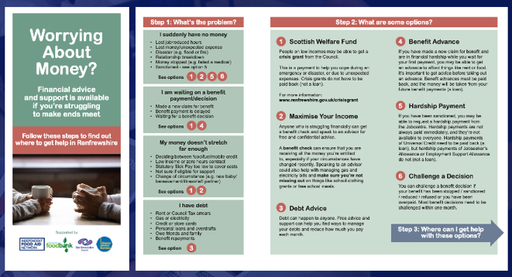  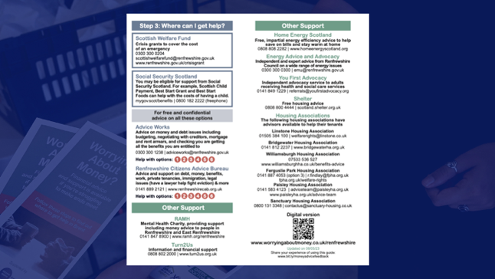  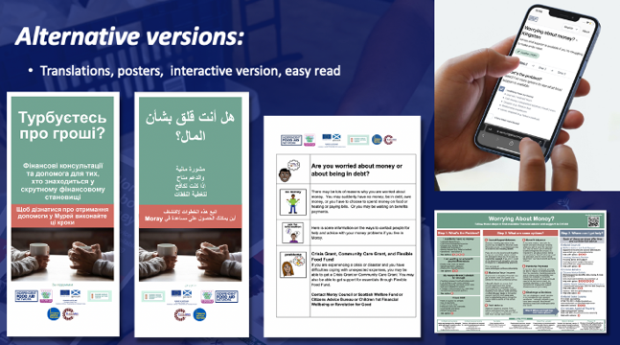 | Use a selection of slides from your local IFAN Worrying About Money? lealfet images and amend the slides accordingly.  Ask if anyone has seen or used the leaflet and take any feedback on this.  First slide:  The leaflet helps individuals identify what the problem is at Step 1:  - suddenly have no money,  - awaiting a benefit/payment decision,  - money doesn’t stretch,  - I have debt.  So lets use the first problem as our example.  I suddenly have no money – options are numbers 1, 2, 5, 6  Step 2 - We can see on this slide what the options for 1, 2, 5, 6 are:  - 1 - Scottish Welfare Fund,  - 2 - Maximise Your Income,  - 5 - Hardship Payment and  - 6 - Challenging a Decision.  If we choose option 1 – that give us A, B & C as options for help  Second slide:  Step 3 – the options were A, B, C – so we can see here that this give us:  - The Welfare Team at Highland Council,  - CAB  - Scottish Welfare Fund.  Each has a phone number as well as a website so if you were in a position to help them make the call or access the website this might mean they are more likely to seek help there and then.  This might be especially true for someone who is in crisis – they might be scared, lacking confidence, not wanting to seek help alone, feeling overwhelmed and not able to make decisions etc.  There are some additional sources of support listed on the back of the leaflet which might also be useful as there could be more than just money issue affecting an individual.  Third slide:  An outline of which alternative formats can be made available  Fourth slide:  Link to online leaflet on IFAN website  This leaflet is specifically for Highland but IFAN are supporting the development of leaflets all over the UK.
 | This section is completely adaptable. IFAN usually delivers Money Counts training sessions together with local advice agencies that are highlighted in Step 3 of the local leaflet. The Renfrewshire session was delivered together with Citizens Advice Renfrewshire. The slides provided an overview of the support the organisation provides in the area.
 | Ask for feedback on how the participants might use the leaflet – encourage people to give verbal feedback but if they want to use chat that is fine too.
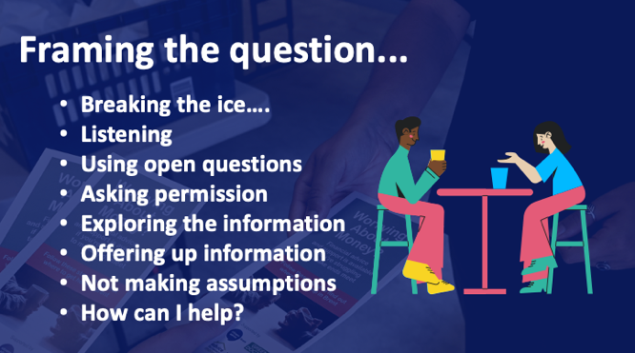 | Please keep this slide  This is about asking the question about money worries well. Listening to hear, using open rather than closed questions, asking permission to give any information, exploring and offering up the information while giving it, the importance of not making assumptions based on what you see and hear and being genuine about offering up help.
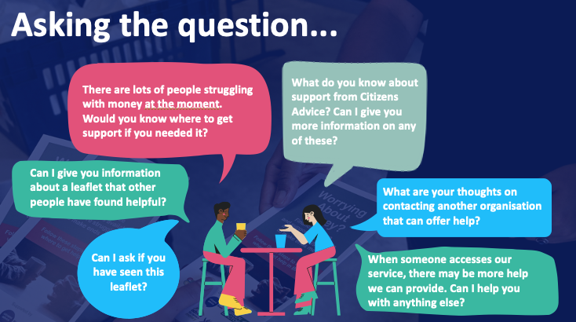 | Please keep this slide  Some examples of what you could say to open the conversation with someone. The key is to ‘offer’ the information in an inclusive and gentle way. People tend to respond better to being offered something than being told it.  Ask for any other example if time allows.
 | Re-do the poll to assess if there has been a shift in confidence and knowledge
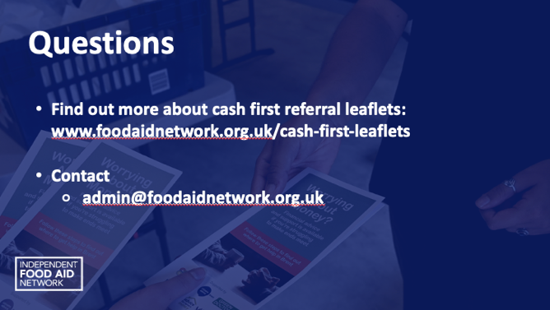 | Ask if there are any questions or comments
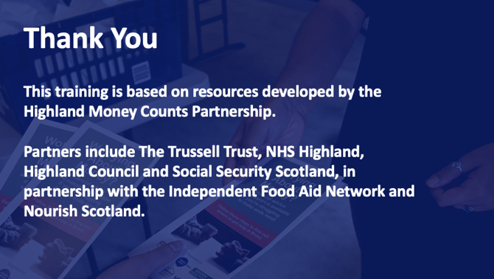 | Please acknowledge that the training has been based on the resources developed in Highland

Additional Information

Tools for polling participants

Participants scores for confidence and knowledge can simply be recorded in the chat and reviewed on course completion.

If using Teams, the Forms app can be added and used to produce an instant poll.

Menitmeter can also be used as can any polling platform which has the functionality to collect participants responses.

Certification for the course

Depending on what platform you use to register participants for the course, it may be able to generate a certificate of attendance.

If you are using Turas, participants can create their own certificate by logging on, choosing the ‘my learn’ tab then ‘learning history’ and all courses attended through Turas should be visible and attendance certificates can be downloaded or printed.

Create a training certificate
You can adapt the certificate in either Publisher or Canva.
Adapting the certificate in Publisher: the blank template is a publisher file. Please add the participants name and appropriate date of the training and then convert it to a more accessible pdf file (which cannot then be changed) for issuing to the individuals by email.
Adapting the certificate in Canva: *In order to edit certificates in Canva you will need to register for your own (free) account. Canva is an online graphical tool that combines design, photo editing, and layout. This is the editable link for the Canva certificate: https://www.canva.com/design/DAEgJFMIBI8/-dBEi04IFMkFrkjB1bToCA/view?utm_content=DAEgJFMIBI8&utm_campaign=designshare&utm_medium=link&utm_source=homepage_design_menu

